What is Unsupervised Learning?
Unsupervised learning is a type of machine learning where the model is trained on unlabeled data — meaning there are no predefined output labels.
The goal is for the algorithm to find hidden patterns, relationships, or structures in the data without explicit guidance.

Feature | Description
Data Type | Unlabeled
Goal | Discover patterns/structures
Output | Clusters, associations, dimensionality-reduced features
Human Role | Interpret results
Common Algorithms | K-Means, Hierarchical Clustering, PCA, Apriori

A. Clustering
Grouping similar data points together.
- K-Means Clustering
  - Partitions data into k clusters based on distance from centroids.
  - Objective: Minimize Within-Cluster Sum of Squares (WCSS).
- Hierarchical Clustering
  - Builds a tree (dendrogram) of clusters.
  - Two approaches:
    - Agglomerative (bottom-up)
    - Divisive (top-down)
- DBSCAN
  - Groups data based on density, can find clusters of arbitrary shapes, and detect noise/outliers.

1. What is K-Means Clustering?
K-Means is an unsupervised machine learning algorithm used for clustering data into K distinct, non-overlapping groups based on feature similarity.
- K = Number of clusters (chosen before running the algorithm).
- Means = The average position (centroid) of points in each cluster.
Goal:
To group similar data points together so that:
- Within-cluster similarity is high (points in the same cluster are close to each other).
- Between-cluster similarity is low (clusters are far apart).

2. Key Concepts
- Cluster → Group of similar data points.
- Centroid → The mean position of all points in a cluster.
- Distance Measure → Most commonly Euclidean distance.

3. How K-Means Works
The K-Means algorithm follows an iterative refinement process:

Step 1 — Choose K
Select the number of clusters (K) to create.

Step 2 — Initialize Centroids
Pick K random points from the dataset as initial centroids.

Step 3 — Assign Points to Nearest Centroid
For each data point:
- Calculate its distance to all centroids.
- Assign it to the cluster with the closest centroid.

Step 4 — Recalculate Centroids
For each cluster:
- Calculate the new centroid as the mean of all points in that cluster.

Step 5 — Repeat
Repeat Step 3 and Step 4 until:
- Centroids stop changing (convergence).
- Or maximum iterations are reached.
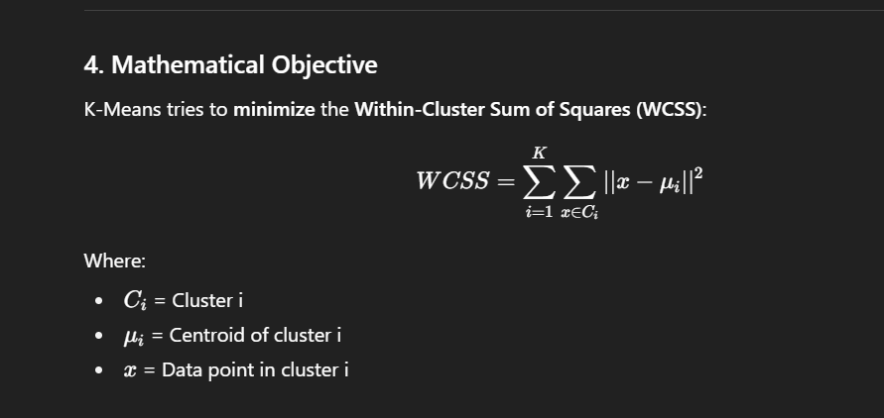

5. Choosing K — The Elbow Method
- Plot K vs. WCSS.
- Look for the "elbow point" where adding more clusters doesn’t significantly reduce WCSS.

6. Advantages & Disadvantages

✅ Advantages:
- Simple to understand and implement.
- Fast for large datasets.
- Works well with spherical, well-separated clusters.

❌ Disadvantages:
- Must choose K in advance.
- Sensitive to outliers and initial centroids.
- Assumes clusters are spherical and of similar size.
- Struggles with non-linear boundaries.

7. Real-Life Applications
- Marketing: Customer segmentation.
- Image compression: Grouping similar colors.
- Anomaly detection: Detecting abnormal patterns.
- Document clustering: Grouping similar articles.
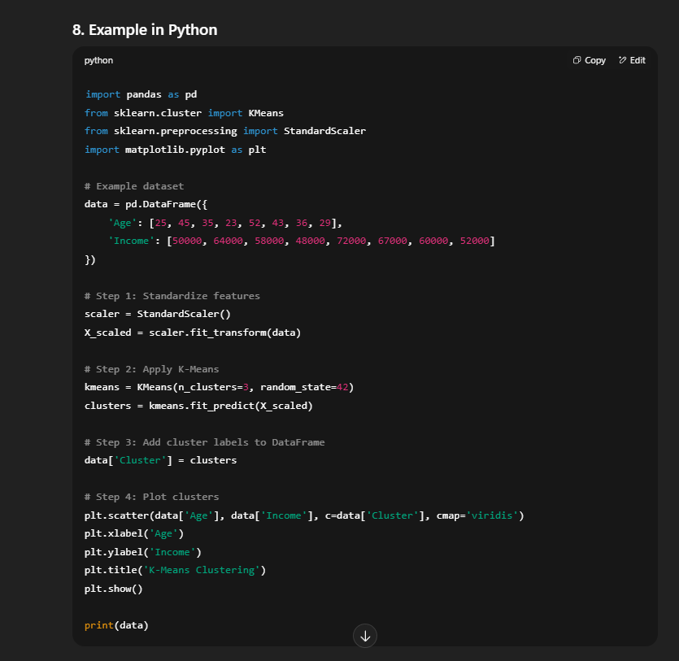

9. Small Visualization of Steps
Initial Centroids → Random placement
Iteration 1 → Assign points → Update centroids
Iteration 2 → Reassign points → Update centroids
Repeat → Until stable clusters.

What is PCA?
Principal Component Analysis (PCA) is a dimensionality reduction technique that transforms a large set of variables into a smaller set that still contains most of the original information.
Instead of looking at data in the original feature space, PCA projects it onto a new coordinate system where:
- First Principal Component (PC1) captures the maximum variance.
- Second Principal Component (PC2) captures the maximum remaining variance, orthogonal to PC1.
- And so on...

2. Why Use PCA?
- To reduce the number of features (dimensionality) for:
  - Faster computation.
  - Reduced overfitting.
- To visualize high-dimensional data in 2D or 3D.
- To remove multicollinearity in features.
- To highlight patterns in the data.

3. Key Concepts
- Variance → Measures how spread out the data is.
PCA aims to capture maximum variance in fewer dimensions.
- Orthogonal Components → Each principal component is at a 90° angle to the others (uncorrelated).
- Eigenvectors → Directions of new feature axes.
- Eigenvalues → Magnitude of variance captured along each axis.

4. Steps in PCA
- Here’s how PCA works step-by-step:
  - Standardize the Data: This ensures all features are on the same scale.
  - Compute Covariance Matrix: Understand how each feature varies with others.
  - Calculate Eigenvectors and Eigenvalues: These define the "directions" and "importance" of the new axes (components).
  - Sort by Importance: Pick the top k eigenvectors (components) that capture the most variance.
  - Transform the Data: Rotate your data into the new coordinate system (Principal Components).
Let’s break it down step-by-step:

Step 1 — Standardize the Data
Why?
If features have different scales (e.g., height in cm, weight in kg), the larger-scale feature will dominate the variance.
Standardization formula:
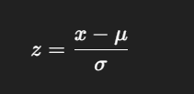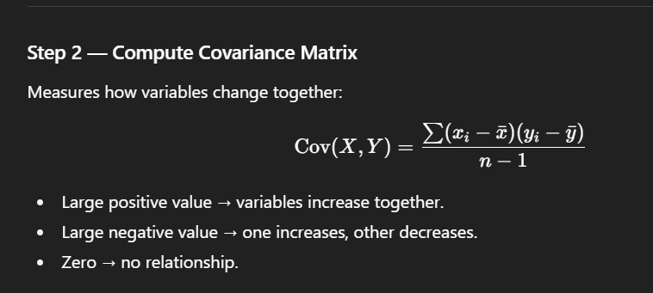

Step 3 — Compute Eigenvalues & Eigenvectors
- Eigenvector → Direction of a principal component.
- Eigenvalue → Variance explained by that component.

Step 4 — Sort Components
- Sort eigenvalues from largest to smallest.
- Keep the top k components that explain the most variance.

Step 5 — Transform Data
- Project original data onto the new principal component axes.
Formula : Z=X⋅W
Where:
- X = Standardized data
- W = Matrix of top k eigenvectors
- Z = Transformed data in new reduced dimensions

5. Choosing the Number of Components
Use a Scree Plot:
- X-axis: Component number
- Y-axis: Variance explained
- Look for the "elbow" — the point where adding more components doesn’t add much variance.
Or use Cumulative Variance threshold (e.g., keep enough components to explain 95% of variance).

6. Advantages & Disadvantages

✅ Advantages:
- Reduces dimensionality → faster training, less overfitting.
- Removes multicollinearity.
- Improves visualization of data.

❌ Disadvantages:
- Components are hard to interpret (no longer original features).
- PCA is linear → struggles with complex non-linear relationships.
- Sensitive to scaling.
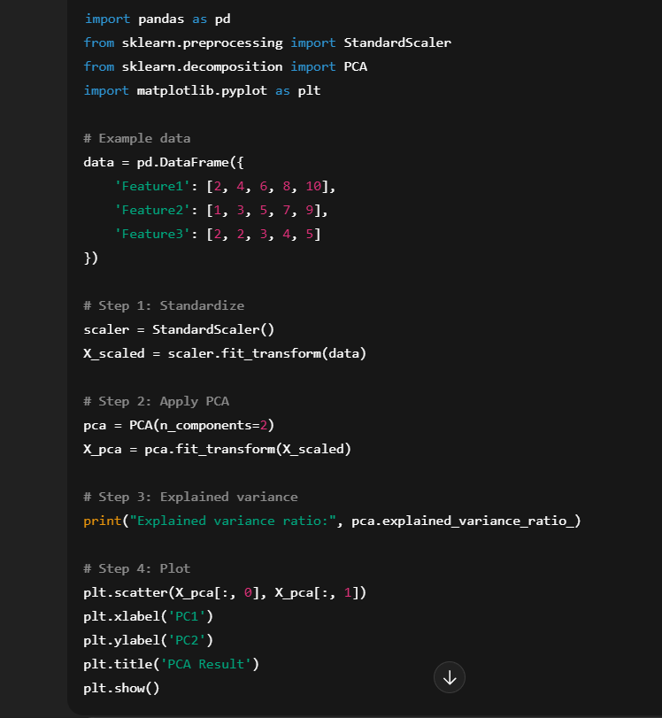

8. Real-World Applications
- Image compression → Reduce pixel dimensions.
- Finance → Reduce correlated indicators.
- Genomics → Reduce thousands of gene features.
- Marketing → Reduce customer attributes for segmentation.
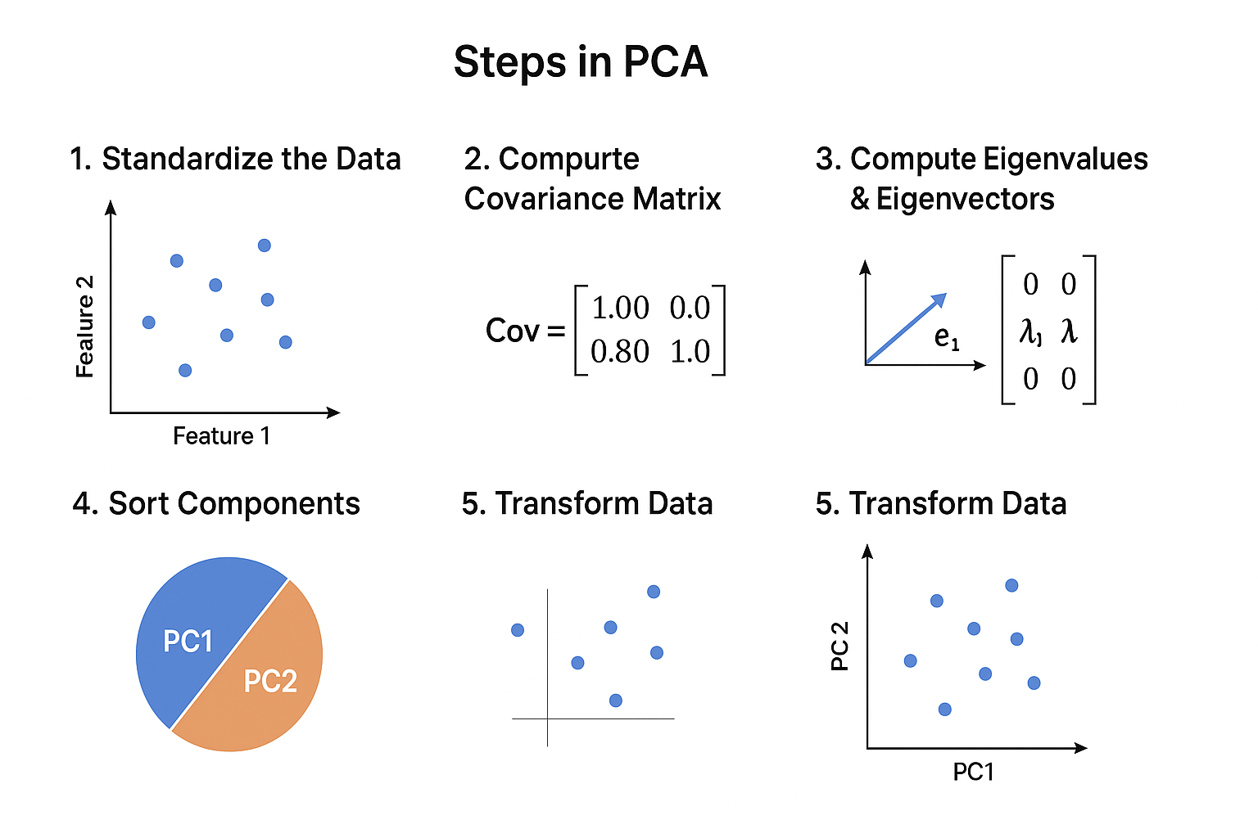

What is DBSCAN?
DBSCAN is a density-based spatial clustering algorithm that groups together points that are closely packed (high density) and marks points in low-density regions as outliers (noise).
Unlike K-Means:
- You don’t have to specify the number of clusters beforehand.
- It can find clusters of arbitrary shapes.
- It can handle noise well.

2. Key Parameters
- ε (epsilon) → Maximum distance between two points for them to be considered neighbors.
- minPts → Minimum number of points needed to form a dense region.

3. Types of Points in DBSCAN
- Core Point → Has at least minPts neighbors within distance ε.
- Border Point → Not a core point but is within ε of a core point.
- Noise Point (Outlier) → Neither core nor border point.

4. How DBSCAN Works
Step-by-step:
- Pick an unvisited point.
- Find all points within distance ε (its neighbors).
- If neighbors ≥ minPts, mark as core point and form a cluster.
- Expand the cluster by recursively adding all density-reachable points.
- If neighbors < minPts, mark it as noise (can later become a border point if it’s near a core point).
- Repeat until all points are visited.

5. Advantages & Disadvantages

✅ Advantages:
- No need to specify number of clusters.
- Can find clusters of arbitrary shapes.
- Handles noise and outliers.
- Works well for uneven cluster sizes.

❌ Disadvantages:
- Performance depends on choosing ε and minPts correctly.
- Not ideal for datasets with varying densities.
- Computationally expensive for very large datasets

6. Choosing ε and minPts
- minPts → Often set to D+1 (D = number of dimensions) or higher.
- ε → Chosen using a k-distance plot (look for the “elbow”).
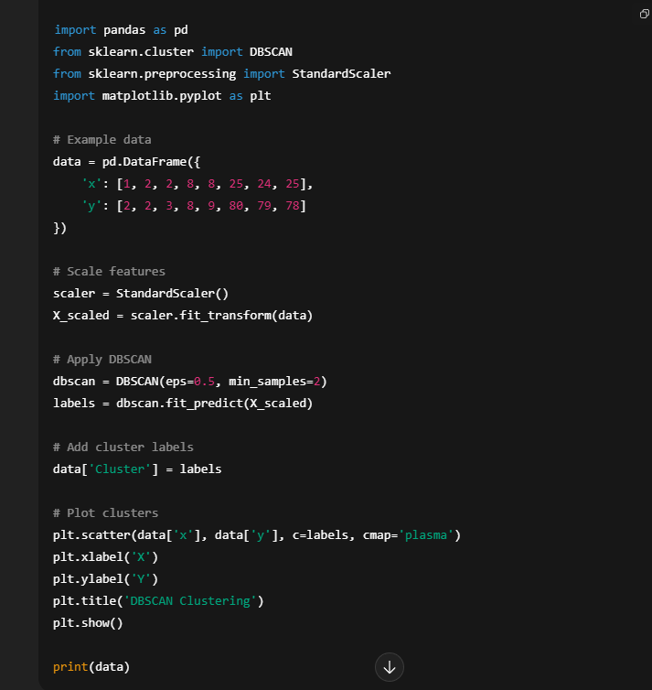
- Cluster = -1 means noise points.
- Other numbers represent different clusters.

8. Real-World Applications
- Geographic data → Finding regions of similar density (earthquake hotspots).
- Astronomy → Detecting star clusters.
- Fraud detection → Spotting unusual transaction patterns.
- Image analysis → Segmenting regions of similar pixel density.
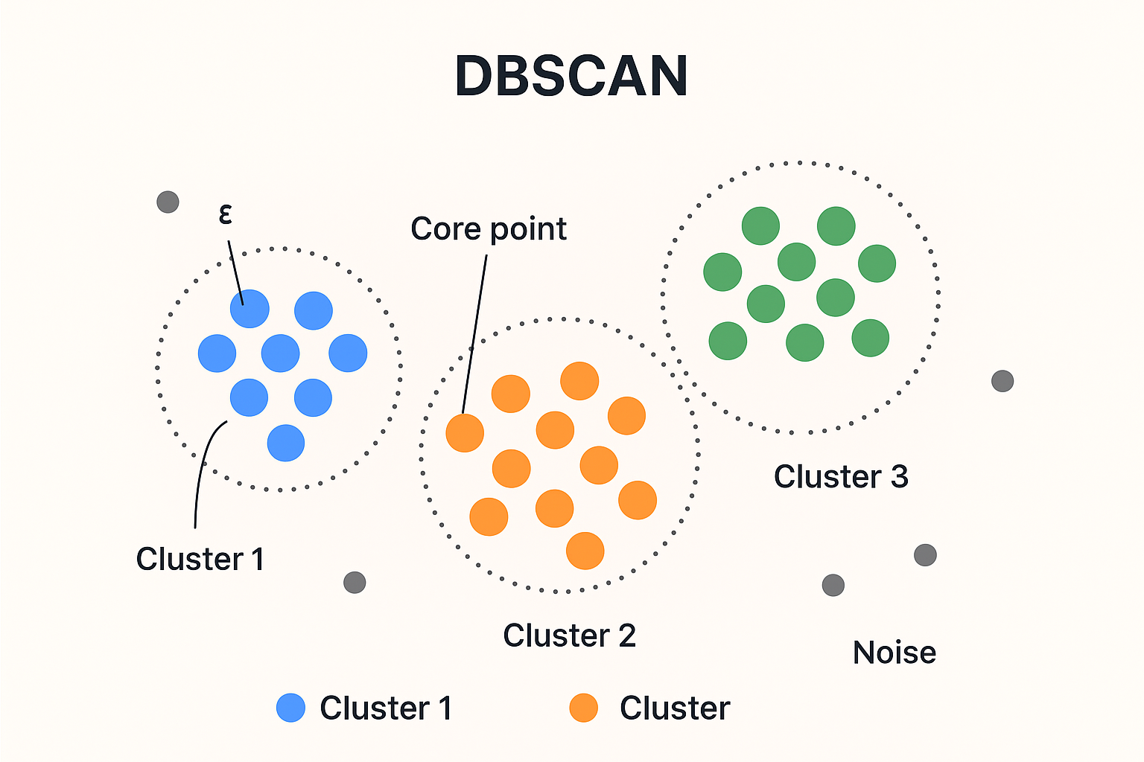

Hierarchical Clustering

Concept
Builds a hierarchy (tree) of clusters.
Two approaches:
- Agglomerative (bottom-up)
- Divisive (top-down)
Most commonly used:
- Agglomerative clustering

Agglomerative Process
- Start with every point as separate cluster
- Merge closest clusters
- Continue until one cluster remains

Linkage Methods
Method | Meaning
Single linkage | Minimum distance
Complete linkage | Maximum distance
Average linkage | Average distance
Ward linkage | Minimize variance

Advantages
- No need to specify K initially
- Produces hierarchy
- Good for smaller datasets

Disadvantages
- Slow for large datasets
- Sensitive to noise

Use Cases

Biological Classification
Grouping genes/species.

Social Network Analysis
Finding communities.

